Tool Guide – Gobuster

Introduction
Gobuster is a powerful command-line tool used in cybersecurity to find hidden directories, files, and DNS subdomains on web servers. It does this by sending a series of HTTP requests based on a wordlist and observing the server’s responses. Gobuster is widely used in the scanning and enumeration phase of penetration testing and is popular for its speed, flexibility, and support for multiple modes including DNS, directory/file, and virtual host enumeration.
Safety Disclaimer: Use Gobuster only on systems you own or have explicit permission to test. Unauthorized scanning is illegal and unethical. Always follow university policies and ethical hacking guidelines.

Setup and Launch

Step 1: Open Deakin Detonator Toolkit
- Launch Terminal in your Kali Linux or other supported Linux environment.
- Navigate to the directory where the Deakin Detonator Toolkit is located:
cd ~/Deakin-Detonator-Toolkit
- Start the toolkit using the command:
yarn run tauri dev
- This will launch the main interface of the toolkit.
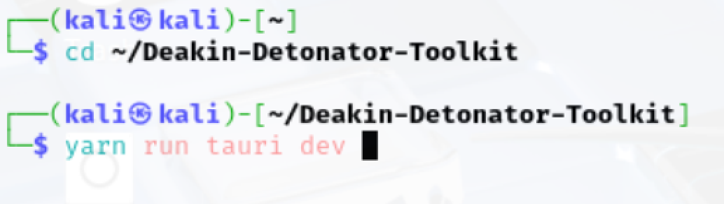
Step 2: Locate the Tool
- Click on “Tools” from the left-hand side menu or use the search bar.

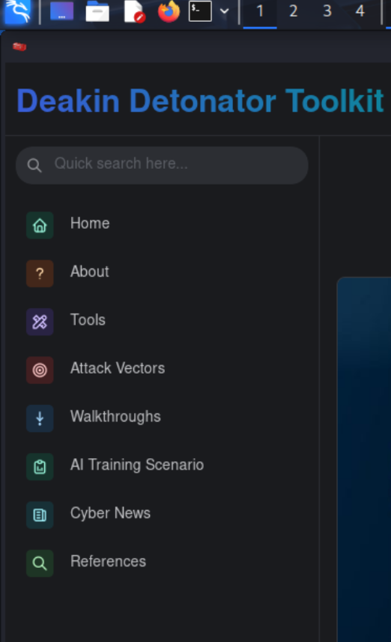

- Look for Gobuster under the Web Application Testing category.
- Click the blue “Go” button next to the tool name to open it.

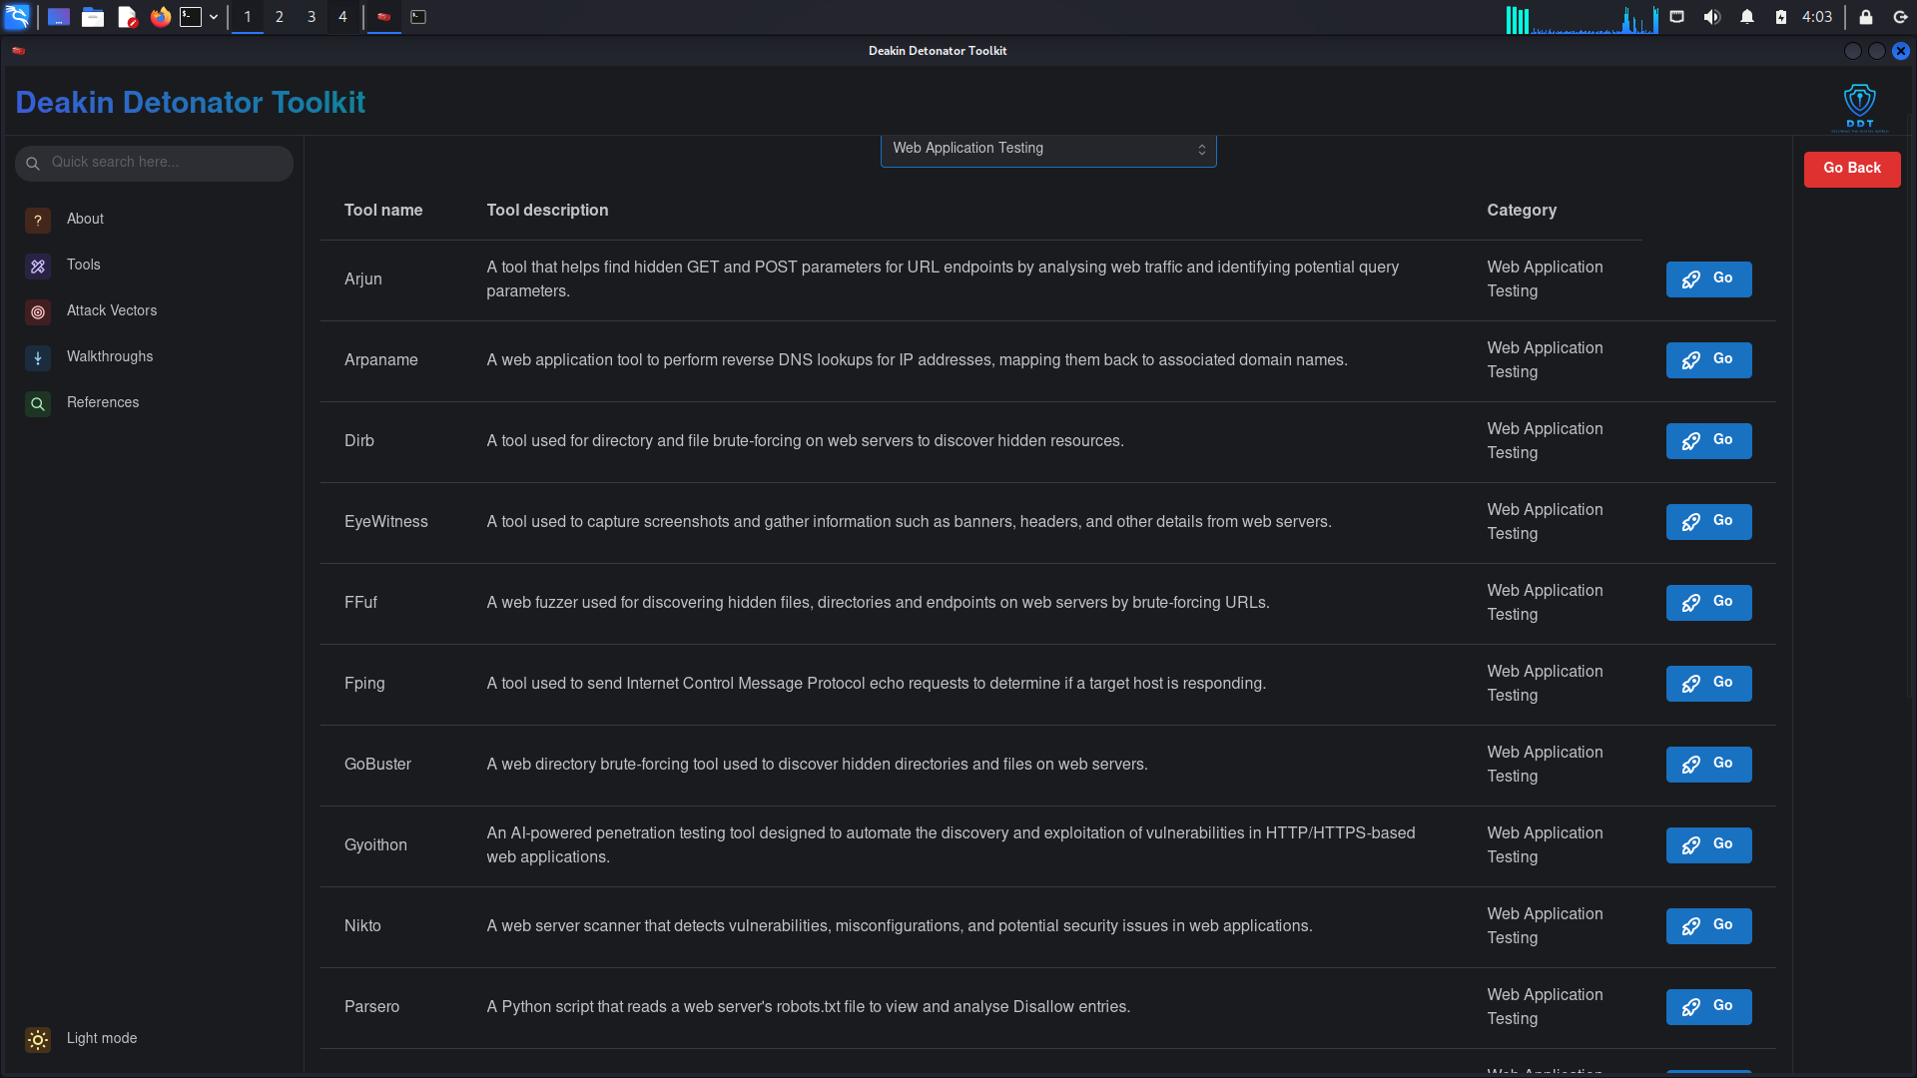
On first launch, it may ask you to install missing components. Click Install and enter your root password to proceed.
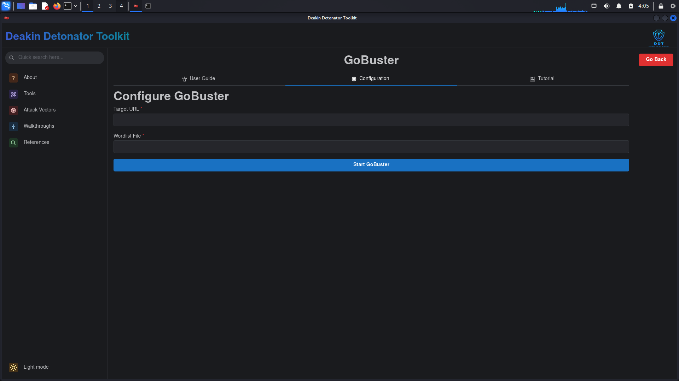

Tool Usage

Step-by-Step Instructions
- Enter the Target URL
E.g., http://example.com
- Choose Wordlist File
Navigate to and select a wordlist (e.g., common.txt).
- Set Threads (Optional)
Default is usually 10. You can adjust based on scan size.
- Set Filters (Optional)
  - Status Codes: Enter 200,301,403 if you only want valid or restricted responses.
  - Extensions: Add extensions like php,html if required.
- Start the Scan
Click “Run” to begin scanning
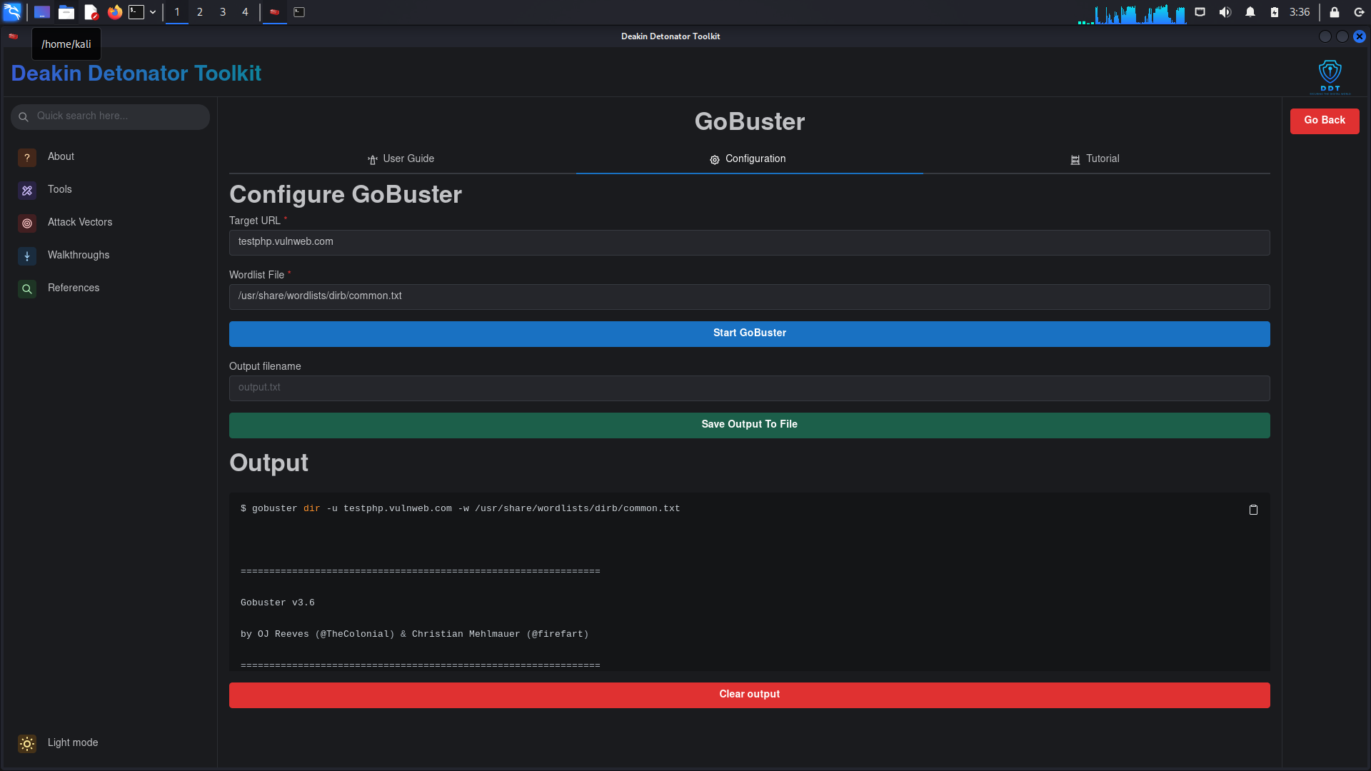

Output & Interpretation
Once the scan completes, the tool will show a list of discovered directories or files along with HTTP status codes.

Sample Output & What It Means
Path Found | Status Code | Meaning
/login.php | 200 | Page exists and is accessible
/admin/ | 301 | Redirects to another URL (e.g., trailing slash)
/config | 403 | Forbidden, exists but restricted
Gobuster automatically hides 404 (not found) responses, making the displayed results more relevant to attackers or testers.



Saving, Clearing, and Resetting

Saving Results
- After the scan, click “Save Output” at the bottom.
- Type a filename like gobuster_results.txt.
- Choose a folder and click Save.

Clearing the Session
- Click “Clear Output” to reset the interface for a new scan.

Troubleshooting
If Gobuster doesn’t open, try restarting DDT by running yarn run tauri dev again and ensure all dependencies are installed.
If you get a “Permission denied” message when scanning, make sure to run the toolkit with root access and approve installation when prompted.
If no results are returned, try using a different wordlist (e.g., big.txt) or confirm the target website is online.
If the wordlist path shows “not found,” double-check the spelling and use the Tab key for auto-completion in Terminal.

